Further expansion as a full-service provider for industrial doors and docking technology
Novoferm takes over the French Norsud Group
Rees, 1 July 2016. The takeover of the Norsud Group by Novoferm was formally signed on Thursday, 30 June 2016. The purchase of the Norsud Group, a leading supplier of industrial doors and docking technologies on the French market, reinforces Novoferm's position as an international full-service provider of products and logistics solutions.

Novoferm, one of Europe’s largest suppliers of Entrance Solutions, is accelerating its growth in France by taking over the Norsud Group. Founded in the 1960’s, the Group has played a leading role on the market for industrial customers through its subsidiaries: Nordsud, GPS and Automanu. The key to this is the wide range of complementary and individually configurable solutions, for example in the fields of industrial sectional doors, high speed doors, roller shutters and docking systems.

With this acquisition, Novoferm is expanding its range of services, improving its presence on the French market as a provider of industrial solutions, and continuing its international strategy. The company’s objective is to be able to offer industrial customers the entire range of products from the field of innovative door and docking technologies from a single source.

Commenting on the deal, Rainer Schackmann, CEO of Novoferm Group said, "The purchase of the Norsud Group will reinforce Novoferm in two respects. This established and recognised partner will significantly improve our ability to support the French market, and the products and solutions of this new Novoferm subsidiary are ideal additions to our range of services. This represents a significant step towards our strategic objective of establishing ourselves, Europe-wide, as a full-service provider for innovative industrial door systems and docking technologies."

The technical competence and the nation-wide coverage of the markets by the four Norsud regional branch offices in Paris, Nantes, Lyon and Marseilles are significant factors that will help to achieve this objective in the near future. At the same time, there will also be synergy effects, particularly in the field of production. Michel Akoum, Managing Director of Novoferm France, also believes that Norsud and Novoferm complement each other perfectly, and regards the takeover as logical: he commented, "We combine industrial know-how in the production of first-class products with experience and technical knowledge in fields like project management and services. The decision to take over Norsud means that we have decided in favour of cooperating with a dynamic and competent team that has detailed knowledge and innovative ideas in the fields of security and optimised docking technology."

By purchasing the Norsud Group, the Novoferm Group in France now employs more than 500 employees, who generate annual sales of over 100 million euro. Today's acquisition underlines the Novoferm Group's claim to expand its role as a supplier of innovative products for industry and to distinguish itself as a specialised partner for docking technology.

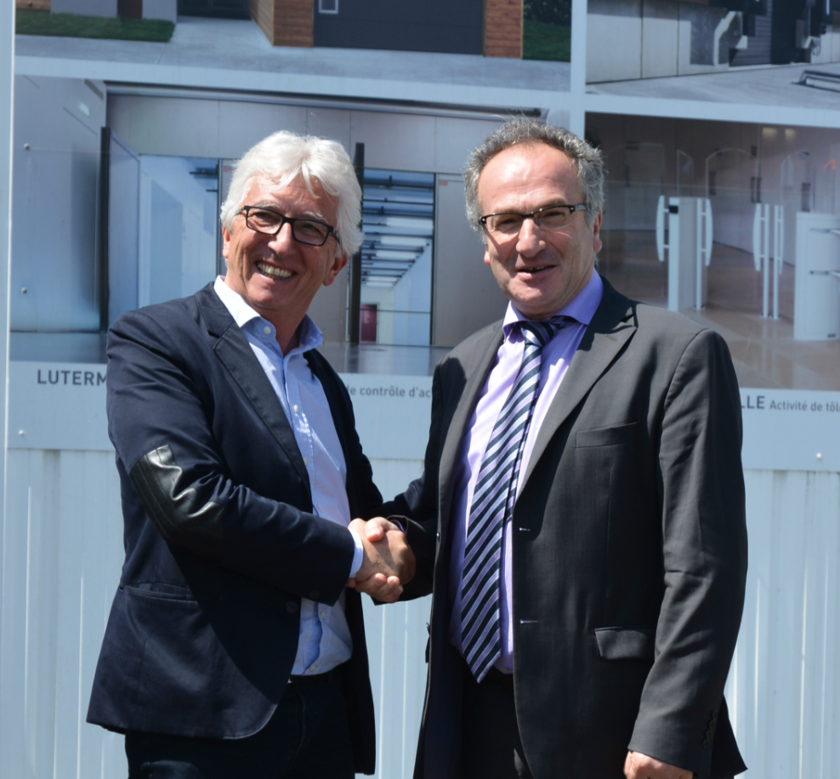

They signed the agreement: Jean-Paul Verge (Managing Director of Norsud, left) and Michel Akoum (Managing Director of Novoferm France, right)

About Novoferm:
Novoferm has been a member of the Japanese Sanwa Group, the world market leader in the field of door and gate systems, since 2003. Novoferm is one of the largest European system suppliers of doors, garage doors, frames and operators for private, trade and industrial sectors, with over 2,000 employees. Established in Rees on the Lower Rhine, the company today has production plants in various locations in Western Europe and Asia, and markets its products in many countries worldwide. Novoferm already has three subsidiaries in France. www.novoferm.fr

About Norsud:
In over 50 years, the Norsud Group has acquired a leading reputation in the market for industrial doors and for equipping loading zones. Norsud is MASE-certified, and plays a particularly active role in questions of industrial safety and safety in assembly work in the field of loading technology. The company employs around 150 persons throughout France.
www.norsud-groupe.fr

> Reprint permitted – Please send copy – Photo: Novoferm <

