Novoferm at BAU 2017
Better looking, faster, safer

Werth, 15 October 2016. Novoferm, one of Europe’s leading system suppliers of doors, garage doors, frames, and operators, has designed its booth concept at BAU 2017 to be a journey of discovery aimed at showing visitors to the trade fair in Munich the full diversity of its powers of innovation. Novoferm will be presenting new products and product variations and optimizations to the trade in realistic worlds on one of the largest booths at the world’s leading construction trade fair in Hall B3 (booth 339). Focus will be on market trends, such as the growing importance of design options for doors, and the increasing demand for reliable solutions that are both secure and improve efficiency.

The five worlds on the 820 sqm area occupied by Novoferm visualize the presence of Novoferm products in virtually all aspects of our everyday lives. As was already the case back at BAU 2015, visitors can expect to see examples of Novoferm solutions that enhance office life, or docking solutions that improve speed and efficiency in industry; further highlights include solutions for car parks and multi car garages, as well as the broad portfolio of products for private customers. The booth will feature a new “Hotels” world, where Novoferm will demonstrate how sophisticated design options can give architects greatly enhanced scope without compromising on functional reliability or standard compliance.

The new NovoPorta Plano is just one example of this trend. As the first “offshoot” from Novoferm’s steel door platform based on the NovoPorta Premio range of doors, this flush closing multifunctional door is ideal, even for sophisticated architectural designs. It enhances offices, surgeries, or sophisticated lounges, hotel or catering environments, for example.
The NovoFire Glass full-glass wall is proof of the growing significance of design diversity. In combination with the NovoFire door, it allows entirely new interior designs while still complying with all fire protection regulations. The options for individual design are further expanded by new additions to the choice of door surface finishes that now include satin dark grey or the Microline pattern.

Visitors to the trade fair can also expect to see a new version of the DuoPort. This thermally insulated double barn door unit turns garages into versatile utility and hobby rooms. Novoferm also provides answers at BAU 17 to the growing yearning for security in private and commercial environments with its presentation of new RC3 tested variants of the NovoPorta Premio model series, for example, or RC2 Apartment packages for sheet steel doors with or without fire resistance. The “Kalashnikov class” bullet resistant doors are also new.

Novoferm is responding to industrial customers’ demands for improved energy efficiency in loading areas/docking solutions with three new products: Alongside new 80 mm industrial doors, a range of rapid roll doors that minimize weather-related thermal losses in logistics will also be presented at BAU 17. The new NovoDock L530 loading ramp has a new NovoSmart operating system for maximum operating ease and efficiency with minimum energy consumption.

One theme at BAU 17 will be the continuous expansion of dialogue-driven customer service offered by Novoferm. These efforts include the relaunch of Novoferm.de as a user-oriented portal for customers and business partners and the programme – which has been exceptionally well received – offered by the Showroom and Training Centre in Dortmund, which only opened in 2016.

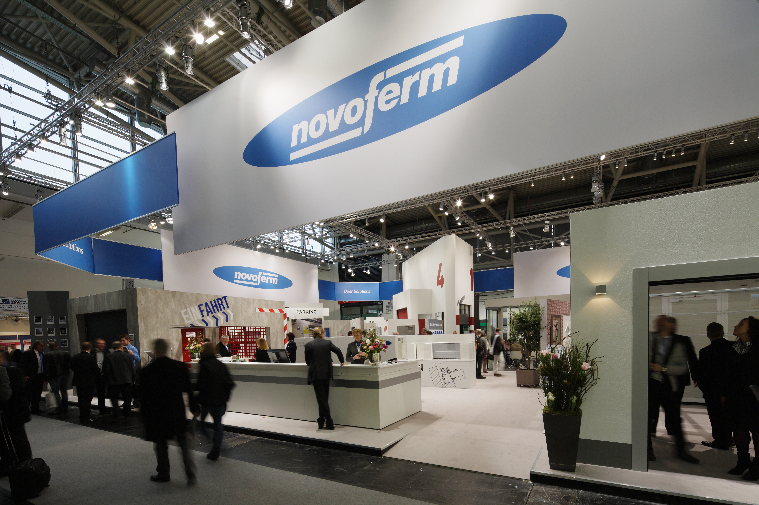
Third-largest exhibitor at the world’s leading construction trade fair:
The Novoferm booth at BAU – which attracted umerous visitors back in 2015.

> Reprint permitted – Please send copy – Photo: Novoferm <

