Platfom strategy proves worthwhile: PREMIO as
an all-rounder and PLANO for high-end design

Werth, October 2018. As one of Europe’s leading suppliers of doors, garage doors, frames and operators, Novoferm has been consistently expanding its portfolio based on the platform strategy launched in 2015 for the NovoPorta Premio and Plano door series. The company will be appearing at BAU 2019 to showcase a range of new solutions designed to suit various requirements and areas of application. The Premio is living up to its reputation as a real ‘all-rounder’ thanks to its new formats and solutions to increase resistance to burglary, fire and bullets. As for the design-oriented Plano, its increased range of sizes along with various extras and accessories mean it is now suitable for use in an even larger range of applications.

The extended sizes of the NovoPorta Premio EI₂ 30 means Novoferm can now meet the demand for larger doors based on its platform concept. As a result, building projects are now more straightforward than ever as planners have a range of matching Premio thick rebate doors to choose from. The Premio EI₂ 30 is now available as a single-leaf door up to a coordinating width of 1500 x 3000 mm, while the double-leaf door is available in formats up to a maximum of 3000 x 3000 mm. In a bid to ensure optimum door leaf stability, Novoferm equips all door leaf heights above 2510 mm with a third door hinge as a general rule. The door can also be supplied with additional smoke protection and soundproofing. What’s more, as is typical for Novoferm products, even the new ‘plus sizes’ are exceptionally diverse in terms of their scope for configuration.

Novoferm is responding to the growing security requirements of commercial and private customers alike with not one but two products. With the Premio RC4 multipurpose security door, Novoferm has developed an extremely stable door constructions that easily meets the strict requirements of RC4 testing. This is achieved through measures including a solid multiple lock mechanism complete with swing bolts. Unlike its predecessor, the E-S 11, the door can also be equipped with electrical lock functions. This ensures the Premio RC4 can be integrated into one of the increasingly popular access control systems. What’s more, the upgrade to the RC2 door types, which are still in popular use, means it also meets the requirements of (even private) customers when it comes to enhanced security.

In light of the growing demand for large-scale bulletproof doors, Novoferm will be showcasing a double-leaf variant of the Premio S-D-2 FB4 RC3 special door at BAU 19. This attractive solution is ideal for use in areas frequented by the general public, such as police stations, courts and other high-security environments, in addition to being appropriate for more discerning private individuals. Despite featuring bulletproof protection to ballistic class FB4 and the RC3 burglar resistance as standard, the exceptional protective functions of the door remain concealed from view. Customers particularly like the fact that the bulletproof special steel inlay is invisible, which means the door looks just like any other Premio.

Another feature appreciated by customers is the range of additional accessories for the single-leaf Premio fire resistant doors EI₂ 30 and EI₂ 90. For operators of large-scale logistics and distribution centres, for example, it is essential to ensure that the fire protection does not impede the general mobility of their employees. Novoferm guarantees this functionality by offering sill-free installation of the Premio EI₂ 30 and EI₂ 90 – including for larger installation heights. The installation of a lowerable floor seal and multilayer foam strips in the bottom U-profile of the door leaf means it is even possible to ensure processes run smoothly in grated gangways in the higher installation levels of the firewall passages.

In addition to convenience, Novoferm also places particular focus on cost efficiency and ease when it comes to installing its door solutions. This is particularly evident in the case of the EasyFit frame backfill for the Premio EI₂ 30, for example, which was first launched in summer 2018 and is ideal for use in dry wall construction projects. Here, a standard corner frame is pre-equipped with special foam that ensures 30 minutes of fire resistance without creating any additional work at the construction site. Just as its motto of “screw on and you’re ready to go” suggests, this solution does away with the usual time-consuming backfill work and minimises the risk of installation errors even for less experienced fitters.

The European outlook of Novoferm is clearly reflected in the product innovations showcased at BAU. As the first manufacturer with a European Technical Assessment (ETA) for interior fire doors, Novoferm has worked hard to achieve CE-marked models in the form of the EI₂ 30 and EI₂ 90. Furthermore, the company has also included the Premio EI₂ 60 in its range as a highly fire retardant door that has already been tailored to meet the needs of international markets. The Premio EI₂ 60 is available as a single-leaf door up to a coordinating size of 1375 x 2500 mm and a double-leaf door up to 2500 x 2500 mm – each with the full range of Novoferm equipment options to choose from.

The flush-closing design of the NovoPorta Plano series, which is also based on the NovoPorta door platform concept, is enjoying growing popularity amongst discerning architects and end users alike as the ‘most attractive fire protection solution’. It is for this reason that Novoferm has launched a range of new sizes for the EI₂ 30 door and developed various equipment upgrades to give this flush model an even more sophisticated and discreet appearance.

The single-leaf Plano can now be delivered in sizes of up to 1375 x 2750 mm. What’s more, the additional features such as smoke protection or the multiple lock mechanism with RC2 burglar resistance are also available for the ‘plus size’ variants. And if that weren’t enough, users can now count on elegant upper sections – whether as a full panel or with large glazed areas – for all single- and double-leaf EI₂ 30 Plano models. These upper sections can, of course, be removed with ease if the passage height ever has to be increased. Last but not least, the Plano and its optional extras such as concealed, stainless-steel-effect hinges and concealed overhead door closers live up to the highest possible standards of design and put these doors undeniably amongst the most elegant fire protection solutions on the market.
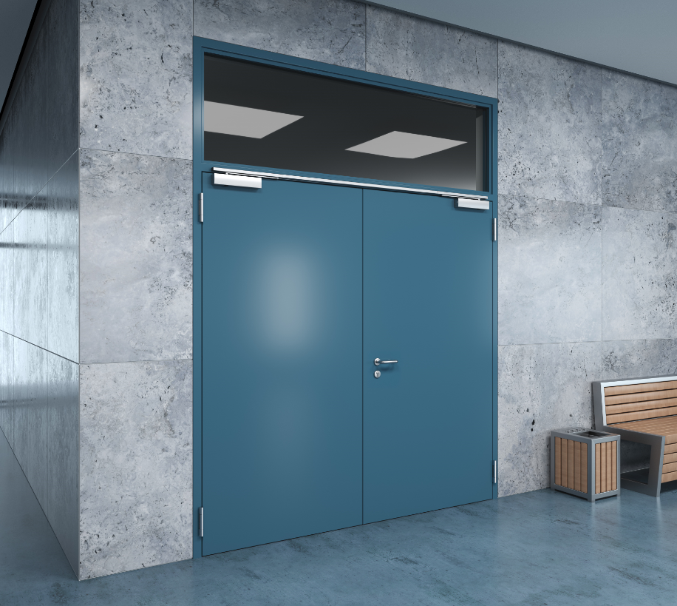
Novoferm has launched a range of new sizes for the EI₂ 30 door in the flush-closing designer NovoPorta Plano series and developed various equipment upgrades to give this flush model an even more sophisticated and discreet appearance.

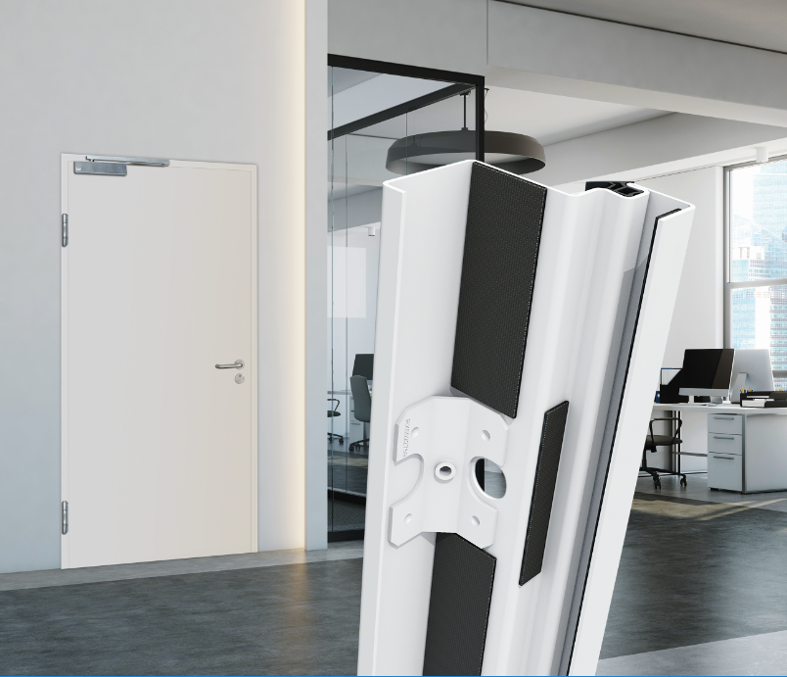
The new Novoferm EasyFit frame backfill with ex works fire protection for NovoPorta Premio EI₂ 30 doors does away with the usual time-consuming backfill work and minimises the risk of installation errors.

Press contact

Novoferm Vertriebs GmbH
Heike Verbeek
Schüttensteiner Straße 26
46419 Isselburg (Werth, Germany)
Tel: +49 (0) 2850 910 435
heike.verbeek@novoferm.de
www.novoferm.de

> Reprint permitted – Please send copy – Photos: Novoferm <

