80 mm doors from Novoferm now with
80 mm ALU NovoLux sections and quadruple glazing

Werth, October 2018. The fundamental criteria defining the quality of industrial doors are speed, operational safety, reliability and the ability to incorporate building-specific design options. Depending on the operator or field of application, factors such as exceptional thermal insulation and light transparency also play a decisive role. As one of Europe’s leading suppliers of doors, garage doors, frames and operators, Novoferm has all of these different requirements covered with its Thermo and NovoLux door series. Novoferm really raised the bar in terms of both thermal and acoustic insulation when it introduced the Thermo 80. Now, the company has launched a new, high-end sectional garage door in the form of the NovoLux 80, which offers virtually limitless possibilities for playing with light and visibility, not to mention an exceptional heat transfer coefficient thanks to its 80 mm panels.

The ability to offer faster, more streamlined processes with as little downtime as possible gives companies within the logistics sector a real competitive edge. Nevertheless, having the appropriate infrastructure in place to accommodate these processes comes at a high price when it comes to energy. This is particularly apparent in ever-larger logistics centres where hundreds of gates guarantee every lorry can be handled in an instant. On the one hand, the quality of the insulation is a decisive factor in the energy balance of the facility, as the doors are ultimately closed for over 90% of the time on average. On the other hand, doors are frequently a crucial component of the architectural light concept and should also complement the overall design. This is everything the NovoLux series stands for, with the NovoLux 80 also offering significantly improved insulation values.

The door leaf in the NovoLux 80 is made up of several sections. The specially dimensioned and thermally separated aluminium profiles allow for diverse frame designs with a huge choice of infill options. The door in the standard version features quadruple glazing with a correspondingly low heat transfer coefficient. What’s more, Novoferm also offers a range of qualities, colours, transparency levels and designs for the panes. The guiding principle behind this approach is the ability to offer “maximum and needs-based functionality with the greatest possible creative freedom for architects”, which applies in equal measure to the design of the NovoLux doors and the overall appearance of the building.

While it goes without saying that the Thermo 80 door from Novoferm also offered creative freedom of design, its developers were certainly more preoccupied with its thermal insulation properties. The door has a significantly lower heat transfer coefficient than the more commonly used doors featuring 40 mm or 60 mm thick panels. But Novoferm has done more than simply reinforce the panels – the exceptional quality of the seals between the panels guarantees a perfect fit. What’s more, the rubber elements used to seal the edges have also been improved in terms of their functionality and thermal properties while the side seals have been triplicated.

Novoferm will be showcasing the NovoLux 80 and Thermo 80 doors at BAU 2019 as its top-of-the-range products that meet the highest standards of functional reliability and state-of-the-art design.

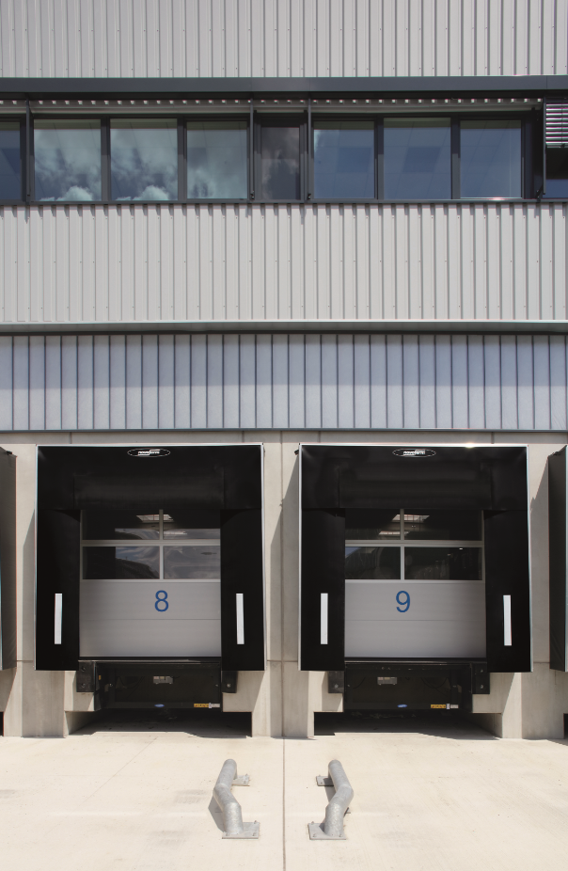

The new Thermo 80 industrial sectional door with ALU NovoLux sections and quadruple glazing as standard offers exceptionally high insulation performance and minimises energy consumption considerably.

Press contact

Novoferm Vertriebs GmbH
Heike Verbeek
Schüttensteiner Straße 26
46419 Isselburg (Werth, Germany)
Tel: + 49 (0) 2850 910 435
heike.verbeek@novoferm.de
www.novoferm.de

> Reprint permitted – Please send copy – Photo: Novoferm <

