NovoFire® Thermo for outdoor use
Transparent structures in
brand new sizes

Werth, October 2018. Until recently, function was favoured over style when it came to external fire-resistant doors. Planners more or less secured fire protection areas with elaborately designed metal doors. Change has been in the air for some time, driven by higher visual standards, the desire for greater transparency to increase the sense of security and, last but not least, by increased requirements as a result of compact constructions. Thanks to the NovoFire® Thermo system products designed for outdoor use, Novoferm is also able to provide elegant and transparent fire protection solutions with the best performance data for precisely these environments. As one of Europe’s leading suppliers of doors, garage doors, frames and operators, the company is also increasing its number of applications and design options: NovoFire® Thermo tubular frame designs are available in this line with a frame height of up to 260 cm.

Metal doors have long been – and continue to be – the solution of choice for fire protection in car-park stairwells or corridors in larger apartment buildings. The only design options were built-in windows that were typically rather small. Today, however, even mundane functional buildings such as car parks need to look the part. Criteria such as openness and transparency are playing an ever-increasing role in subjective residential conditions and comparative car park reviews.

Even frequently narrow stairwells are nightmares for many users who are unimpressed with plain, unadorned flights of stairs lit with cold artificial light behind the access door. Metal doors between stairwells and passageways with doors leading off to a series of apartments are no longer considered a contemporary solution. When it comes to increasing the general acceptance and marketability of apartment blocks, transparency, natural light and tasteful frame designs are essential. This is why fire doors with large glass panels and elegant frame designs are becoming more and more important in renovations and new builds. A third area of application includes external doors in spaces with compact constructions. Fire-resistant doors are not only fitted in sections of the building as firewalls, they are also needed for exits that are near firewalls in neighbouring buildings.

NovoFire® Thermo aluminium fire-resistant doors provide perfect solutions for this wide range of uses. The extensive range of sizes is really quite impressive. A large number of equipment components that can be combined as needed also make it an ideal solution for a wide range of different designs.

The robust NovoFire® hollow profiles with a 4 mm wall thickness are the key components of this system. Fire-resistant insulation developed by Novoferm guarantees the construction’s 30-minute fire resistance time and high insulation properties. Thanks to a maximum height of 260 cm and building depth of 90 mm, spacious, light passages can be achieved in previously unknown dimensions. It is also on account of this format that Novoferm can offer its customers proven high resistance to driving rain because doors measuring higher than 250 cm must meet stricter test criteria. The 260 cm NovoFire® Thermo effortlessly meets these requirements – and the smaller sizes too.

With EI₁ 30 C5, NovoFire® Thermo meet the highest requirements in reducing surface temperature in the event of a fire and therefore provide higher levels of safety than required by building regulations. The single-leaf door can also be fitted with a smoke-proof system.

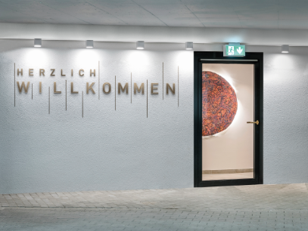
NovoFire® Thermo aluminium fire doors offer perfect solutions for a wide range of applications, such as this single-leaf design (EI 30) as a side entrance to a hotel car park.

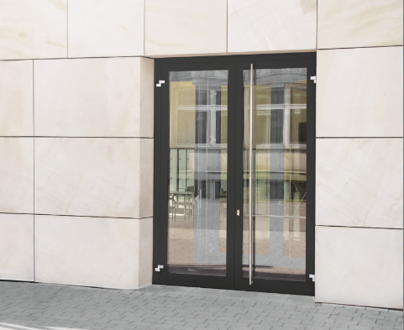
Example of a double-leaf NovoFire® Thermo aluminium fire door (EI 30) as an emergency exit door.

Press contact

Novoferm Vertriebs GmbH
Heike Verbeek
Schüttensteiner Straße 26
46419 Isselburg (Werth, Germany)

Tel: +49 (0) 2850 910 435
heike.verbeek@novoferm.de
www.novoferm.de

> Reprint permitted – Please send copy – Photos: Novoferm <

