EVO X Leveller – safer, faster
and more efficient thanks to digitalisation

Werth, October 2018. The ideal goal of every logistics specialist is to ensure smooth processes while maintaining maximum transparency during every phase and using resources efficiently. There is a need for optimisation in this respect in all aspects of the loading process, in particular for large warehouses and logistics centres. During loading and unloading, the objectives of speed and safety must be balanced, and the more loading bridges and doors an object has, the more difficult it is to keep an eye on all processes at all times and to optimally coordinate the way the bridges are used. As one of Europe’s leading suppliers of doors, garage doors, frames and operators, Novoferm has now developed the EVO X to meet these requirements. As the next generation leveller, it combines intelligent safety technology with digital information management and control that is as simple as it is fast.

The developers at Novoferm set themselves the goal of designing the safest and most efficient state-of-the-art leveller. The result is the EVO X – the top model that offers almost all marketable innovations as standard. An example of this is the patented iQ Slide, which eliminates one of the greatest accident risks during loading.

iQ Slide and SLOD

The SLOD function, as it is known, provides additional safety: The feed is set with just one control button so that the gap between the ramp and the loading area is bridged before the lorry is opened. This allows the back door of the lorry to be opened safely. iQ Slide is the first intelligent feed. If a lorry or semi-trailer is pushed forward by a forklift truck driving forwards, the feed follows automatically, preventing it from slipping off the truck.
For the transition from lorry to the leveller, Novoferm uses segments made of high-strength aluminium. Their length makes them especially secure. The aluminium slide system ensures a particularly smooth and even transition. This is good for the forklift driver’s back and protects the transported goods. In addition, Alu-Slide is much quieter than other systems and the optional Silence Plus coating further enhances this effect.

Simple, fast and safe operation

The EVO is operated using the Novo i-vision X, a control system with which all functions, including iQ Slide, SLOD and the time-saving QuickDock, are triggered at the touch of a button. The LED user guidance system largely eliminates operating errors. What’s more, as is usual with Novoferm’s innovations, the latest environmentally friendly technologies have been used. In addition, energy consumption can be reduced by up to 70 per cent thanks to a new power-saving function.

While the EVO X ensures noticeable improvements in each individual loading process, Novoferm can also be combined with the innovative LION 4.0 software, enabling continuous monitoring and optimum use of all loading points – at any time and from any location. LION provides information on the current status of one or all gates and bridges, their duration and frequency of use.

Information Management for Transparency and Efficiency

The LION 4.0 dashboard is a sophisticated graphical user interface that visualises data such as loading cycles or the average loading duration of the entire plant. The export function allows internal benchmarks as well as comparisons with other centres. If desired, the system can also actively contact the employees responsible: The system can be set to send information to mobile phones or email addresses.
For example, the system actively and automatically informs about deviations or unusual use of gates and bridges. It also shows the actual wait status – the EVO X is not maintained rigidly by calendar, but according to practical necessity, i.e. the actual load. The option of remote monitoring makes it possible to dispense with location-dependent supervisors or administrators. The EVO X thus becomes a prime example of the use of digital technologies for maximum security, efficiency and transparency in loading management.

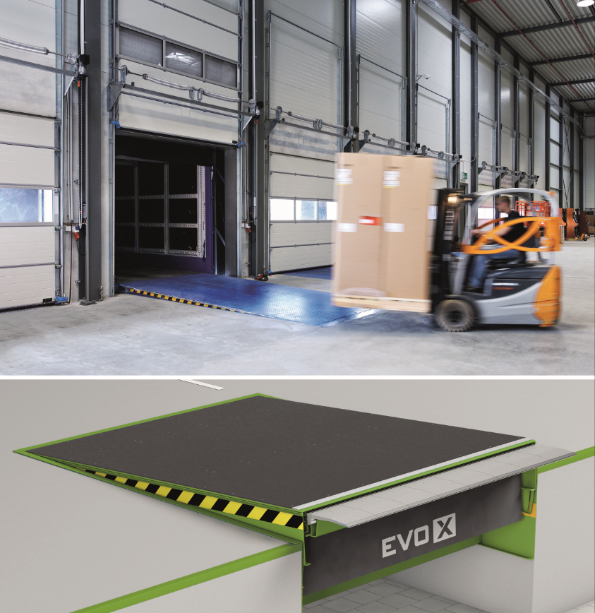
With the EVO X, Novoferm is introducing the next generation of levellers. It combines intelligent security technology with digital information management and control that is as simple as it is fast. Increasing safety and increasing efficiency go hand in hand.

Press contact

Novoferm Vertriebs GmbH
Heike Verbeek
Schüttensteiner Straße 26
46419 Isselburg (Werth, Germany)
Tel: +49 (0) 2850 910 435
heike.verbeek@novoferm.de
www.novoferm.de

> Reprint permitted – Please send copy – Photos: Novoferm <

