NovoPort® system operator improved yet again

Better looking, safer and more convenient

Werth, October 2018. More convenience, additional functions, added security and an attractive design – as of 1 November, customers purchasing Novoferm door systems can take advantage of the latest generation of the NovoPort® system operator. As one of Europe’s leading suppliers of doors, garage doors, frames and operators, Novoferm will now be offering its newly improved NovoPort® as standard with every door system order (with the exception of other ongoing promotions). What’s more, the developers at Novoferm even had the foresight to ensure that the previous model can be replaced by the new NovoPort® with ease. The fastening points are identical on both units and even the connection terminals have been designed to follow the tried-and-tested Novoferm logic.

This new version of the NovoPort®, which has really stood the test of time, sees Novoferm incorporate the very latest technology and design elements into its successful operator system. The company was very keen to take customer expectations on board during the design process. The subject of security is becoming increasingly important – after all, nobody wants to switch to the convenience of a remote-controlled garage door only to find that this involves a greater risk of burglary. But with the new NovoPort®, customers can relax in the knowledge that they are in the safest hands as the automatic signal encryption via AES128 means the remote control comes complete with the best possible protection against manipulations.

Another innovation takes the form of the now bi-directional control via a 3-channel rolling code hand transmitter that facilitates a ‘dialogue’ between the transmitter and control unit. At the touch of a button, users can retrieve information on the door status as multicoloured LEDs provide feedback within seconds on whether the door is open, closed, ajar, in motion or in the ventilation position. Not only does this allow users to enter the garage without having to wait, it also puts an end to the constant worry of “did I definitely remember to close the door?”.

In spite of these additional functions, it still couldn’t be easier to operate the NovoPort® at the touch of a button. The same also applies when it comes to programming the Mini-Novotron 523 Protect transmitter as users are guided systematically through the three-button menu. But even this process is only a one-off ‘effort’, since the settings made here are saved indefinitely – even in the event of a power cut. It also goes without saying that the operator can even be controlled by external push buttons, key buttons or a remote coded key pad.

The rising demand for premium, sophisticated-looking door surface finishes means Novoferm is well aware that garage owners are becoming increasingly interested in a designer look down to the last detail. This is why it was so important when designing the new edition of the NovoPort® operator system to ensure that customers can be proud of every last component. Similarly, the control unit and hand transmitter have been designed to complement the elegance of the popular, high-end Novomatic ceiling operators.

In addition to these innovations, the impressive new NovoPort® still boasts all of the same features that set its predecessor apart. These include the integrated wall-mounted keypad and the energy-saving LED lighting that can be supplemented with external lamps via the corresponding connections. Even the option to leave the door ajar to ventilate the garage can be activated at the touch of a button, with the system then closing the door again automatically after 60 minutes. Other features of the new NovoPort® include the soft start and stop functions and the easy-to-follow diagnostic system.

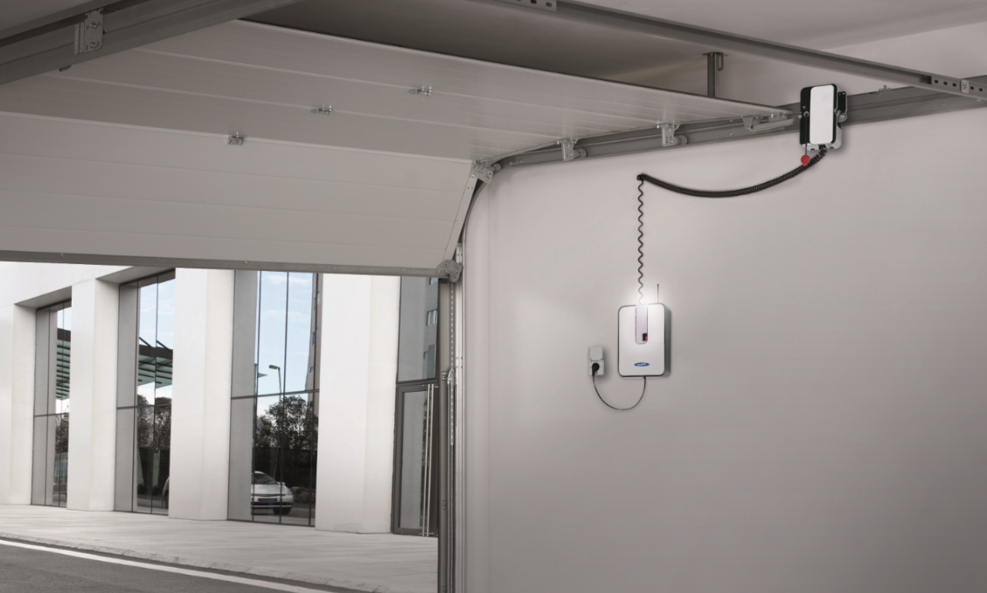
In addition to the popular benefits of its predecessor, the new version of the impressive NovoPort® system operator also features a whole host of technical innovations and a straightforward, intuitive, design-driven appearance.

Press contact

Novoferm Vertriebs GmbH
Heike Verbeek
Schüttensteiner Straße 26
46419 Isselburg (Werth, Germany)

Tel: +49 (0) 2850 910 435
heike.verbeek@novoferm.de
www.novoferm.de

> Reprint permitted – Please send copy – Photo: Novoferm <

