The possibilities are endless:

Novoferm introduces a “European” sliding
fire door in the form of the NovoSlide Industry

Werth, January 2019. The introduction of the harmonised European product standards for fire-resistant seals (EN 16034) and doors (EN 13241) represented a major step forward in terms of the ongoing harmonisation of the European Single Market. Nevertheless, there are still a number of different building regulations relating to fire protection that also apply in each of the member states. This is why Novoferm – as one of Europe’s leading suppliers of doors, garage doors, frames and operators – has launched a new generation of sliding fire doors that meets the requirements for all standard European fire resistance classes in full. The NovoSlide Industry is expected to be available across Europe from the middle of 2019, and can be reliably used in each of the member states as a CE-marked component. What’s more, the NovoSlide Industry also boasts the usual range of Novoferm equipment and installation options.

When companies are planning projects such as pan-European industrial facilities or commercial buildings, the process of dealing with country-specific fire-protection requirements often creates additional work and expense. The same applies for companies offering products and services relating to fire protection in various countries: the time scales for sliding fire doors to seal off fire compartments reliably, for example, can vary between 30, 60, 90 and in some cases even 120 minutes. With the NovoSlide Industry, Novoferm has developed a “European sliding fire door” that complies with all standard time classes in each of the different EU states – from EI₂ 30 to EI₂ 60 and EI₂ 90 and even up to EI₂ 120. It therefore goes without saying that the NovoSlide Industry meets the European product standards EN 16034 and EN 13241 for fire-resistant seals and doors.

The new sliding door not only offers “endless” possibilities in terms of where it can be used, it is also sure to impress with its reliability, added extras and a whole host of available options in terms of size, equipment and installation. Novoferm will be offering the NovoSlide Industry as both a single and double door unit, in addition to as a telescopic door unit, in dimensions up to 8500 x 6000 mm. It is due to these large dimensions that Novoferm attaches particular importance to the ease of installation and strong running behaviour of this door. Another useful optional feature of the NovoSlide Industry comes in the form of an accessible wicket gate.

Customers can benefit from these technical specifications virtually regardless of the wall type or other building-related conditions. NovoSlide Industry is designed to suit all common installation types and can be adapted to suit a wide range of different building requirements thanks to the variety of equipment options available. Of course, it goes without saying that the overall appearance is always sure to impress. Features such as the smooth surface of the new sliding door combine with the flush design of the cladding for the tracks and counterweights to create an attractive look that simply oozes quality.

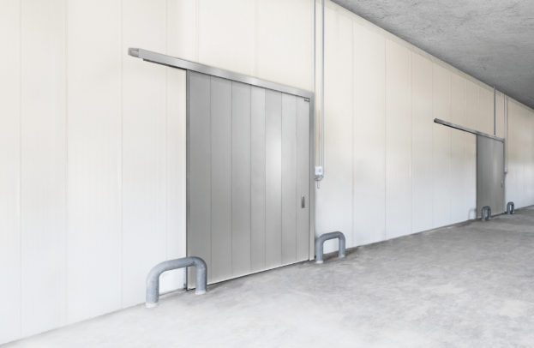
The new NovoSlide Industry sliding fire door from Novoferm has been specially developed to comply with exacting European product standards. This means it can be used reliably across Europe as a CE-marked component.

Press contact

Novoferm Vertriebs GmbH
Heike Verbeek
Schüttensteiner Straße 26
46419 Isselburg (Werth, Germany)

Tel: + 49 (0) 2850 910 435
heike.verbeek@novoferm.de
www.novoferm.de

> Reprint permitted – Please send copy – Photo: Novoferm <

