iso 70 Premium Plus high-end sectional door:
Maximum energy efficiency, smooth
running and flawless design

Werth, January 2019. Modern garages have been more than storage rooms for vehicles for some time now. They are seen by the owners as a fully fledged part of the house and should therefore meet the highest functional, qualitative and aesthetic standards: In an energy-efficient house, the garage must not turn into a heat sink, operating noises must not impair living comfort, and the garage should ideally match and complement the design of the building. At BAU 2019, Novoferm will be presenting the iso 70 Premium Plus, a sectional garage door that sets new standards in all three areas – energy efficiency, smooth running and design. This high-end solution can also be upgraded with the newly developed Novoferm photoelectric sensor and integration into smart home systems.

With the new iso 70 Premium Plus sectional door, Novoferm – as one of Europe’s leading suppliers of doors, garage doors, frames and operators – is promising maximum energy efficiency for garage doors. This is ensured by the thermally separated sections of the door with additional seals, which are equipped with a PUR rigid foam core. The values are further improved by using an optionally available tailor-made sealing and insulating strip system: The Novoferm Thermo frame set can further improve the insulating effect by up to 15 per cent. To ensure that the resulting U-value of 0.9 W/m² K* is fully utilised, the door is always fitted with double bottom seals.

Particularly in the case of garages integrated into the framework of the building, door noises or even slight vibrations or shocks can be unpleasant and impair living comfort. This is not the case for the iso 70 Premium Plus: The standard tandem rollers of the new sectional door guarantee extremely smooth door travel when opening and closing, thus ensuring that the door is exceptionally quiet when in use.

But it’s not just the constructional features that make the Premium Plus solution from Novoferm impressive. It is also a joy to look at, both inside and out. The inside of the door has a well-kept and uniform appearance, as the door leaf, hinges and profiles are harmoniously coated in RAL 9016. Because of its discreet appearance, the RAL colour “traffic white” is often used indoors – for example, for light switches, sockets or window frames.

Once again, Novoferm offers a particularly wide range of design options for the design of the exterior. Both the modern, contemporary large rib pattern and the timelessly elegant flush pattern with its smooth premium surface finish can be combined with the various options in the wide range of Novoferm designs. All satin surfaces are available, as well as the “warm” wooden surfaces. Novoferm also supplies the iso 70 Premium Plus in the customer’s preferred colours, or a paint finish in the chosen RAL colour. Glass windows can also be installed without problems and without significantly impairing energy efficiency – Novoferm relies on proven triple glazing for all window sizes and formats.

The design features of the iso 70 ensure comfortable operation and a particularly long service life for this top-class door. In addition, Novoferm engineers always keep an eye on personal safety: as standard, the sectional door on the new thermally separated panels is equipped with finger protection both outside and inside. Anyone who wants to equip their iso 70 Premium Plus with extra safety protection will opt for the new Novoferm photoelectric sensor, specially developed for garage doors.

Whether the door is controlled from a distance by a hand transmitter or smartphone from a greater distance, the light barrier reliably detects whether objects or persons are obstructing or even endangering the operation of the door. Assembly and setup of the light barrier are as simple as they are self-explanatory: screws are not required and the correct mounting position is ensured by perforations at the frame and, once installed, Novoferm drive systems automatically detect the light barrier.

*Door size: 5000 x 2125 mm when combined with a Thermo frame set

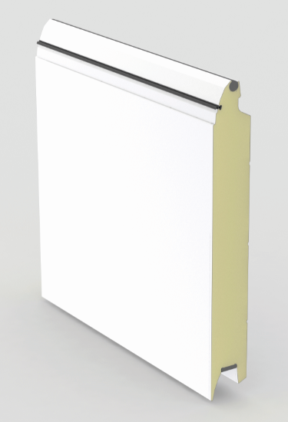
The new iso 70 Premium Plus sectional door represents a fantastic upgrade for your garage – the thermally separated sections with PUR rigid foam core and additional seals between the sections provide extra points in thermal insulation. The garage door achieves maximum energy efficiency thanks to double bottom seals in conjunction with a U-value of 0.9 W/m² K*.

Press contact

Novoferm Vertriebs GmbH
Heike Verbeek
Schüttensteiner Straße 26
46419 Isselburg (Werth, Germany)

Tel: +49 (0) 2850 910 435
heike.verbeek@novoferm.de
www.novoferm.de

> Reprint permitted – Please send copy – Photos: Novoferm <

