New rapid-roll doors: A reliable choice that meets market demand

Werth, January 2019. Novoferm is expanding its range of rapid-roll doors once again. As one of Europe’s leading suppliers of doors, garage doors, frames and operators, Novoferm consistently meets the changing – and, above all, growing – demands of customers for more efficiency, safety and individual solutions. In fact, it is with these growing demands in mind that the company is gradually expanding its range of rapid-roll doors to include new products. Not only do the impressive rapid-roll doors from Novoferm offer a remarkable opening speed, but in many cases they also come complete with a light curtain as standard and even boast a new design.

Logistics specialists across Europe are constantly on the lookout for ways to make their processes faster and more streamlined, with loading situations offering the most obvious room for improvement. After analysing customer requirements across Europe, the Research & Development department at Novoferm has now launched the new NovoFold, which really does exceed expectations in many respects. The unique folding-door solution has been designed to seal large-scale openings such as those found in the industrial sector. Comprising a PVC curtain (900 g/m²), which is available in nine different colours, the NovoFold relies on a series of belts to open and close the door system. It also comes complete with steel wind reinforcements in special pockets designed to make the door system exceptionally resistant to wind. As a result, it is capable of withstanding wind loads up to Class 5. All things considered, the NovoFold from the Novoferm Group really is an exceptionally reliable product.

Another new product comes in the form of the NovoZip, which is designed for indoor use. This flexible, self-repairing, PVC rapid-roll door is the ideal solution for busy passages where speed is a top priority. What’s more, its exceptional impermeability also saves valuable energy.

The rapid-roll doors from Novoferm are designed to meet the growing demand for speed, occupational safety, diversity, design, and overall ease of installation and maintenance. This is achieved through features including an opening speed of 1.5–2.0 m/s and a standard light grid to increase occupational safety.

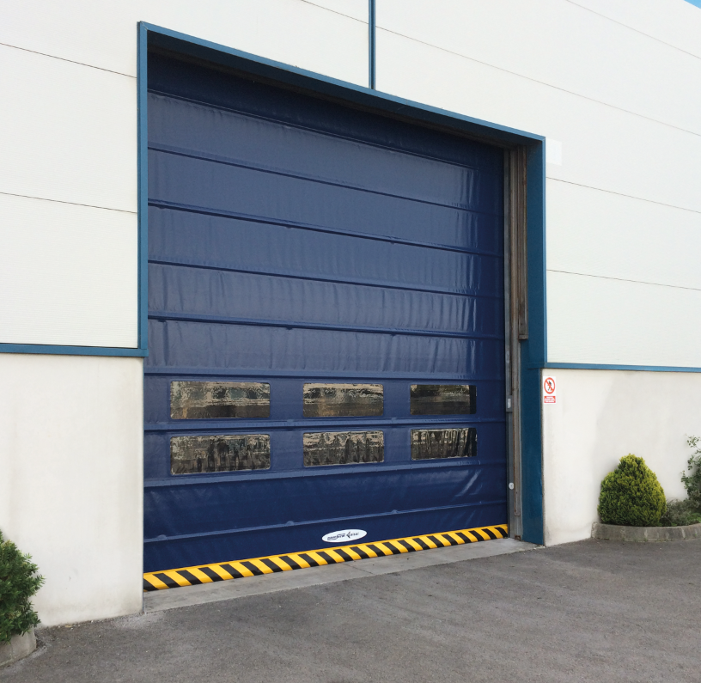
The newly developed NovoFold rapid-roll folding door supports logistics processes in a variety of ways, but particularly thanks to its efficient functionality and exceptional stability.

Press contact

Novoferm Vertriebs GmbH
Heike Verbeek
Schüttensteiner Straße 26
46419 Isselburg (Werth, Germany)
Tel: + 49 (0) 2850 910 435
heike.verbeek@novoferm.de
www.novoferm.de

> Reprint permitted – Please send copy – Photo: Novoferm <

