Novoferm standard corner frames with ex works frame backfill
Installing fire-resistant doors is
easier, safer and more cost effective with EasyFit

Werth, January 2019. Even the best fire-resistant door can only guarantee its fire-resistant properties if the frame is expertly installed in line with the necessary approvals. Unfortunately, both the installation and the necessary backfilling of the frame are highly time-consuming manual tasks that are prone to errors. With its innovative EasyFit system, Novoferm is the first and – until recently – sole provider of standard corner frames with pre-installed special foam. This ex works fire protection makes the installation process faster, safer, cleaner and more economical. The frame backfill with expanding fire-resistant foam strips ensures a fire resistance time of 30 minutes and is therefore the ideal solution for 1-leaf and 2-leaf T30/EI₂ 30 Premio doors by Novoferm.

The EasyFit system by Novoferm, one of Europe’s leading suppliers of doors, garage doors, frames and operators, makes installing fire-resistant doors in exposed masonry and exposed concrete significantly easier in combination with a rebate bolt mounting. The benefits of the new system are even greater in dry wall construction, where time and speed are of the essence. The frame backfill needed requires a high amount of organisational effort and time and opens up a range of sources of error. As a result, the approval for the corresponding backfill material needs to be sought and complied with on the construction site; the installers must also factor in a large amount of time and work extremely carefully on backfilling because even the tiniest of errors may impact the fire-resistant properties of the door element.
The use of Novoferm EasyFit rules out all errors associated with backfilling the frame. The installer does not need to take any specifics into account, the frame is only installed with the mounting equipment provided and the usual tolerances. When it comes to dry wall construction, this means that the EasyFit system is ideally fitted with the 2140B 2-part surrounding frame and upper door closer in steel stud walls with at least F30-A. Novoferm also provides the complete installation set (screws, dowels, open door closer, self-adhesive plastic cover profile) for use with standard corner frames and rebate bolt mounting in exposed masonry and concrete. An option is also available if a 2-part surrounding frame design is required.

These easy assembly systems are possible since the frames have already been made fire resistant in the workshop. In addition, Novoferm fits strips made from a specially foaming intumescent fire protection material into the frame. The material expands in temperatures above 200°C, ultimately reaching 10 to 40 times its original volume and reliably seals the gap between the frame and the wall. As a result, EasyFit guarantees 30 minutes of fire resistance. The system has been tested to EN 1634 and is building code approved as T30-1 and T30-2 as per DIN 4102. The NovoPorta Premio with EasyFit system classified as EI₂ 30-1 or EI₂ 30-2 based on the European Technical Assessment ETA – 17/0443 is available as an option.

As a result, EasyFit can be installed for all T30/EI₂ 30 variants in the whole Premio size range for single and double-leaf doors. This also refer to doors with additional features such as smoke protection and sound insulation; plus, thanks to the simple Easy Fit assembly system, there is no risk of doors and frames surface coated with the desired RAL colour being damaged or stained when backfilling at the site.

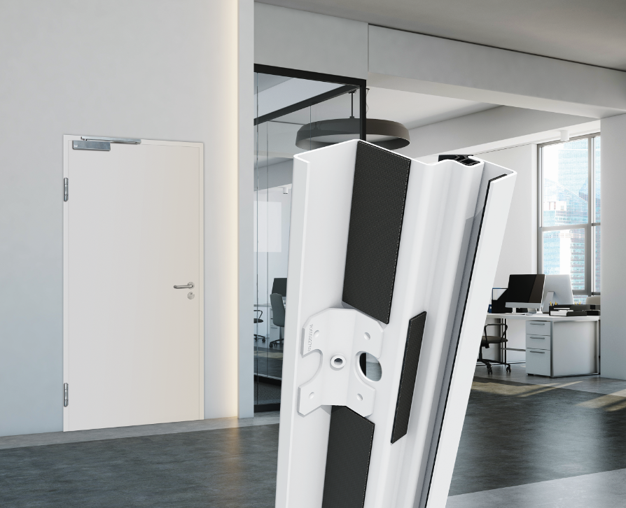
Requires no additional time-consuming backfilling. NovoPorta Premio frames with ex works fire resistance. EasyFit – screw on and you’re ready to go!

Press contact

Novoferm Vertriebs GmbH
Heike Verbeek
Schüttensteiner Straße 26
46419 Isselburg (Werth, Germany)

Tel: +49 (0) 2850 910 435
heike.verbeek@novoferm.de
www.novoferm.de

> Reprint permitted – Please send copy – Photo: Novoferm <

