NovoSlide Wall Rapid

Don’t slide – glide: An impressive new door system
offering convenience, elegance and versatility

Werth, January 2019. Automatic sliding doors have long since been part of the furniture in retail outlets and public buildings. Unlike in countries such as Italy or France, however, they still remain an exception to the rule in apartment blocks, offices and clinics. With the new NovoSlide Wall Rapid sliding door, Novoferm is ensuring that these markets can now also benefit from a smooth-running solution. This door system, which sits in front of the wall, serves to visibly improve the overall appearance of private and commercial spaces alike. The integrated intelligent maglev operator is an impressive feature that offers highly flexible control options. The NovoSlide Wall Rapid is both a technologically advanced and extremely elegant door option that quite literally creates more space, enables barrier-free access, and is even suitable for buildings with a high level of footfall thanks to its maintenance-free operator and control options.

The NovoSlide Wall Rapid is the result of the systematic further development of the manual sliding door system, the NovoSlide Wall. The impressive NovoSlide Wall is designed for doors with steel, wood, glass or aluminium frames. It also features premium-quality rolling carriages that move along a robust, aluminium-veneered track with a stainless-steel effect. It is this combination that facilitates a particularly smooth and straightforward sliding motion of the door leaf up to a weight of 120 kg.

The NovoSlide Wall is also available with an optional space-saving two-way damping mechanism, which makes it possible to keep installation widths to a minimum. As a result, even extremely narrow doors can benefit from two-way damping. Additional ease of use is ensured by means of a high-quality floor tracking system comprising a guide roller and an aluminium profile that can be embedded within a wooden door leaf. Last but not least, steel passageway frames transform the NovoSlide Wall into a highly functional and durable overall system. These robust passageway frames are equally suitable for installation either at the same time as the wall or at a later stage. They are available in three or six parts, which means transporting them to and around the construction site couldn’t be easier.

As one of Europe’s leading suppliers of doors, garage doors, frames and operators, Novoferm offers an optional low-energy magnetic operator that transforms a conventional sliding door into a state-of-the-art gliding door that can be just as easily secured to the wall or ceiling. This operator allows the door leaves to glide almost without making any sound at all. Users have the option to activate this function by proximity sensor, app or remote control, or simply by pressing a button. Alternatively, for a fully automated opening experience, it is even possible to incorporate infrared sensors.

The NovoSlide Wall Rapid comes complete with a whole host of refined technical features to ensure maximum convenience and safety. These include automatic obstacle detection and the ability for the system to learn the end positions automatically. The door opening and closing speeds can be adjusted as required and the ‘touch-to-go’ mode means even the most gentle contact with the door triggers the automatic opening action.

Buildings such as doctors’ surgeries or offices in particular are ideal for highlighting the benefits of yet more customisable options. These include individually definable hold-open times ranging from 5 to 30 seconds and a ‘permanently open mode’ where the door remains open until the button is pressed a second time.

The NovoSlide Wall System will be available for delivery from April 2019.

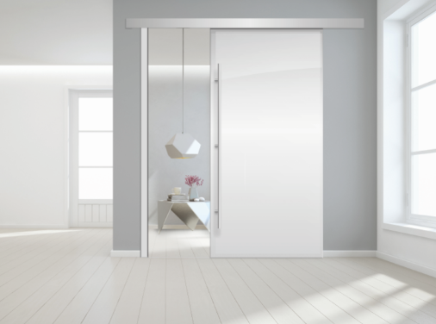
Serene elegance – the quiet new NovoSlide Wall Rapid sliding door from Novoferm is sure to impress with features including extremely quiet operation and a sophisticated stainless-steel finish.

Press contact

Novoferm Vertriebs GmbH
Heike Verbeek
Schüttensteiner Straße 26
46419 Isselburg (Werth, Germany)

Tel: + 49 (0) 2850 910 435
heike.verbeek@novoferm.de
www.novoferm.de

> Reprint permitted – Please send copy – Photo: Novoferm <

