Digital networking for Novoferm operators:

Make the garage part of every smart home:
Simple, safe, convenient and open to all systems

Werth, January 2019. The ‘Internet of Things’ is not only changing products and processes within companies, but also bringing greater convenience and security to the private sector. Intelligently controlled household appliances, heating and alarm systems, roller shutters and even front doors can all communicate with each other and with property owners to transform a property into a truly intelligent smart home. With this in mind, integrating the garage – or, more specifically, the garage door operator – into this equation is the obvious and logical next step, particularly as leading suppliers such as Novoferm are already offering app-based garage door control systems. Novoferm will therefore be showcasing a major breakthrough at BAU 2019: the full functionality of all newer garage door operators can now be controlled centrally via the app, meaning all sectional garage doors from Novoferm can now become a ‘smart’ component of an intelligently networked home.

As one of Europe’s leading suppliers of doors, garage doors, frames and operators, Novoferm has been keen to forge ahead with an open-system concept. As a result, the Novoferm garage control can be easily integrated into the most popular (and consistently free) apps on the market, such as the Homematic IP app from eQ-3, the SmartHome app from Innogy and the TYDOM app from Delta Dore. What’s more, it’s even self-configuring. The additional hardware required includes a Novoferm plug-in module and a smart home hub from the respective supplier.

Novoferm is clearly highly attuned to the wide range of requirements in this growing market. For those who have been thinking about making their home ‘smart’ for some time, the garage door control is the ideal first step. This offers the perfect opportunity for customers to experience a ‘trial run’ to find out whether the chosen app lives up to their expectations in terms of ease of operation and functionality. The other functions can then be easily connected for all current products on the market. Novoferm’s open-system concept also guarantees that the process of adding the garage door control to existing smart home systems is as straightforward as can be. Novoferm operators can be integrated into existing smart home systems in just a few short steps – all it takes is for the operator to be equipped with the corresponding Novoferm plug-in module.

The ease with which it is possible to control and program heating, air-conditioning, lamps, alarm systems, roller shutters and awnings via any touch screen also applies to accessing the status and full functionality of garage door controls. The gesture-controlled and intuitive operation of the apps allows customers to find out the door status any time, anywhere, and open or close it accordingly. If that weren’t enough, the operator lighting, garage ventilation and even additional sectional doors can also be controlled by smartphone or tablet, and it goes without saying that the Novoferm operators can even ‘follow orders’ via voice control as long as this feature has been included by the app developers.

All Novoferm operators (NovoPort®, Novomatic 423 and Novomatic 563 S) manufactured in 2016 or later are designed to be smart home ready. All Novoferm sectional garage doors are suitable for integration into a smart home system. For those interested in the any time, anywhere control functionality, the standard Novoferm power limiter and opto sensor protection are required.

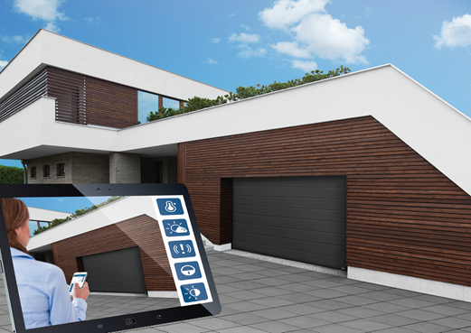
A smart home app makes it easier than ever to operate a Novoferm sectional garage door from anywhere: all it takes is a finger swipe across the touchscreen to open and close the sectional garage door, control the lighting, and even listen to operator parameters.

Press contact

Novoferm Vertriebs GmbH
Heike Verbeek
Schüttensteiner Straße 26
46419 Isselburg (Werth, Germany)

Tel: + 49 (0) 2850 910 435
heike.verbeek@novoferm.de
www.novoferm.de

> Reprint permitted – Please send copy – Photo: Novoferm <

