First joint project launched
Novoferm and KIWI sign a partnership agreement

As one of Europe’s leading system suppliers of doors, garage door solutions and loading systems, Novoferm has launched a partnership with KIWI.KI GmbH, a pioneer in digital door access solutions. The objective of this partnership is to integrate the KIWI system in Novoferm products. There are plans for a range of projects, the first of which introduces KIWI technology to Novoferm doors for communal and underground garages and is already underway. The next step will be to equip multifunctional sheet steel doors with the KIWI system.

“The partnership with KIWI is another logical step in our successful digitalisation strategy – which is now also being introduced in the highly promising growth market for digital door solutions,” said Norbert Dyx, Managing Director at Novoferm Vertriebs GmbH. “KIWI has the necessary expertise in digital access and security technology. Combined with our innovative products, this will mean that we can offer the ideal solutions for housing companies and provide them with even better support as a partnership.”
KIWI Managing Director Karsten Nölling explained: “Supplying doors and garage doors with a digital lock system ex works is the next logical step in our success story. Many housing companies have already replaced their existing mechanical lock systems with our digital solution and now we are able to offer all-in-one solutions alongside Novoferm. This enhances the efficiency of our portfolio management, both for new construction and for renovation projects. Many of our new construction customers are already using our fully equipped SmartDOOR, a front door with integrated KIWI lock system. We want to work with Novoferm to follow up on these good experiences.”

Novoferm and KIWI have already launched their first joint project: Novoferm doors for communal and underground garages are already available with the KIWI system. Another major project involving the integration of KIWI functions in Novoferm multifunctional steel doors is in the planning stage. The steel doors with digital opening technology are expected to be available from mid-2020.

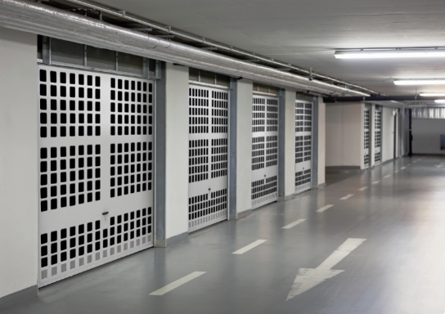
Novoferm up-and-over doors for parking spaces in communal garages are now available fitted with KIWI lock systems featuring digital access and security technology.

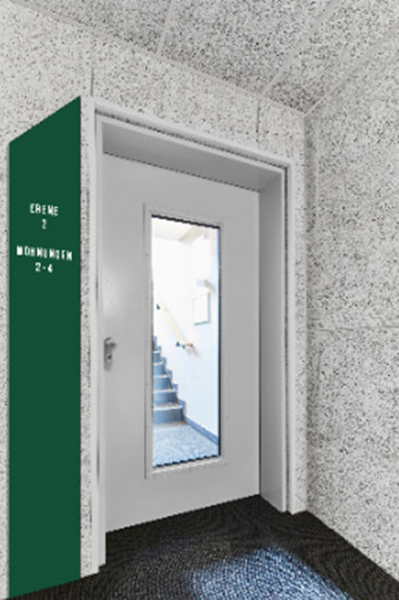
Another digital all-inclusive solution is planned: Novoferm multifunctional steel doors fitted with the KIWI lock system will follow in mid-2020.

About Novoferm
Novoferm is one of the largest European system suppliers of doors, garage door solutions and loading systems for private, commercial, and industrial use. The company was established in the Lower Rhine region in 1955 as Isselwerk Werth GmbH and has been part of the Japanese Sanway Group (owned by the Sanwa Holdings Corporation) since 2003. The Novoferm Group has production plants in various European locations and sells products in many countries worldwide through a number of subsidiaries and sales partners. Novoferm has more than 3000 employees and is ISO 9001 certified. Find out more at www.novoferm.de
Novoferm press contact
Novoferm Vertriebs GmbH
Heike Verbeek
Schüttensteiner Straße 26
46419 Isselburg (Werth)
Germany
Tel. +49 (0) 2850 910435
heike.verbeek@novoferm.de

> Reprint permitted – Please send copy – Photos: Novoferm <

About KIWI.KI GmbH
KIWI is the keyless access system for front and apartment doors of apartment buildings. Access authorisations can be centrally managed via the KIWI portal. Building managers no longer need to run around buildings or have to worry if they have the right key at the right time and the right place. More than 105,000 residential units are connected to the KIWI infrastructure and KIWI’s customer base includes over 600 housing companies. Today, doors are opened more than 500,000 times a month using KIWI systems. KIWI is a service provided by KIWI.KI GmbH. The company, which is headquartered in Berlin, was founded in February 2012. Its CEOs are Karsten Nölling, Chairman of the Board, and Hannah Nöthig. More information is available at www.kiwi.ki.
KIWI press contact
KIWI.KI GmbH
Julia Rubin, Head of Marketing
Wattstraße 11
13355 Berlin
Germany
Tel. +49 (0) 30 609 83 8350
julia.rubin@kiwi.ki

